Test Case: tc001_SPX_Dev5_Crear_Nueva_Linea_Requisicion_Spot_Tipo_Cobro_CC
Step 1 - Enter username and password and click to button Enter : Credentials Entered
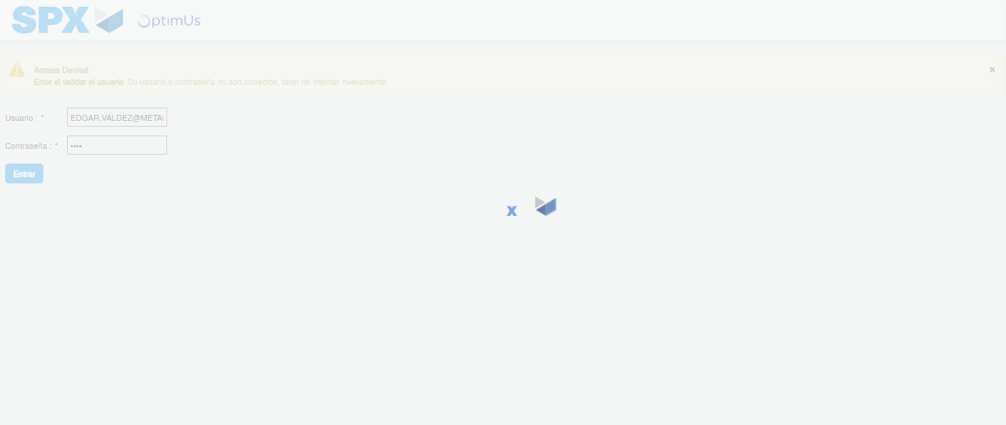Image file-name: QC_Testing-tc001_SPX_Dev5_Crear_Nueva_Linea_Requisicion_Spot_Tipo_Cobro_CC-1781316220398

Step 2 - Select to UEN and Access to Spot Buy Requisitions : UEN Correctly selected and Correct access
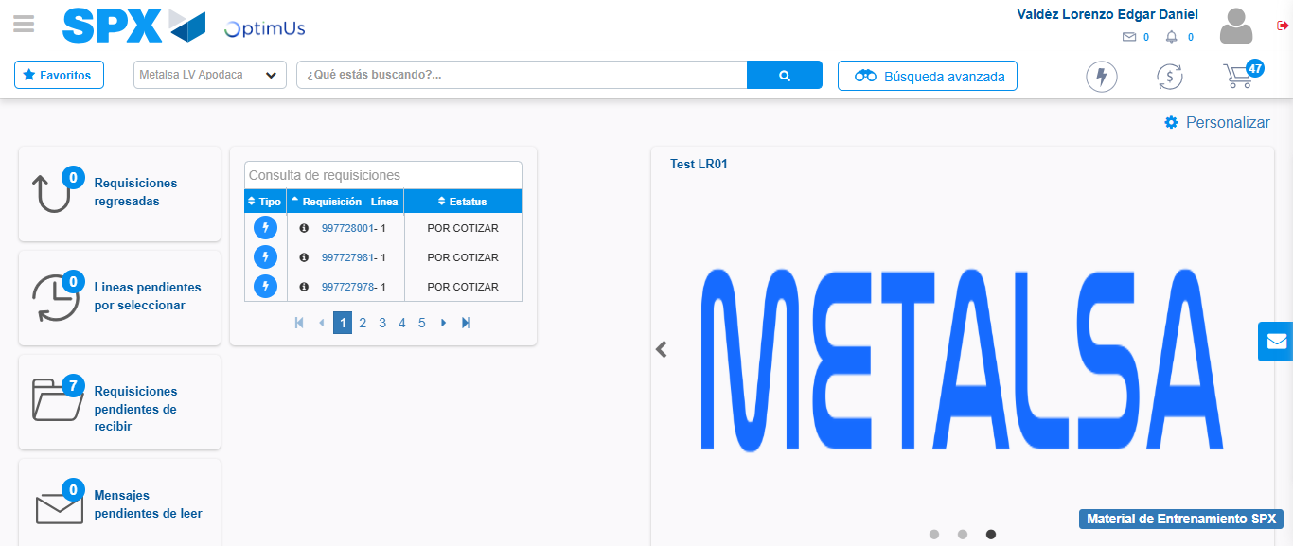Image file-name: QC_Testing-tc001_SPX_Dev5_Crear_Nueva_Linea_Requisicion_Spot_Tipo_Cobro_CC-1781316245380

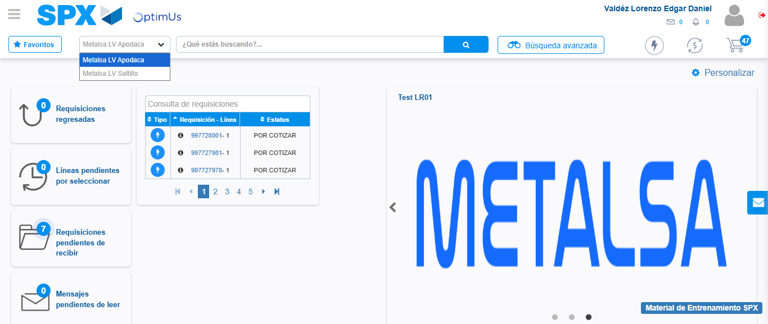Image file-name: QC_Testing-tc001_SPX_Dev5_Crear_Nueva_Linea_Requisicion_Spot_Tipo_Cobro_CC-1781316248005

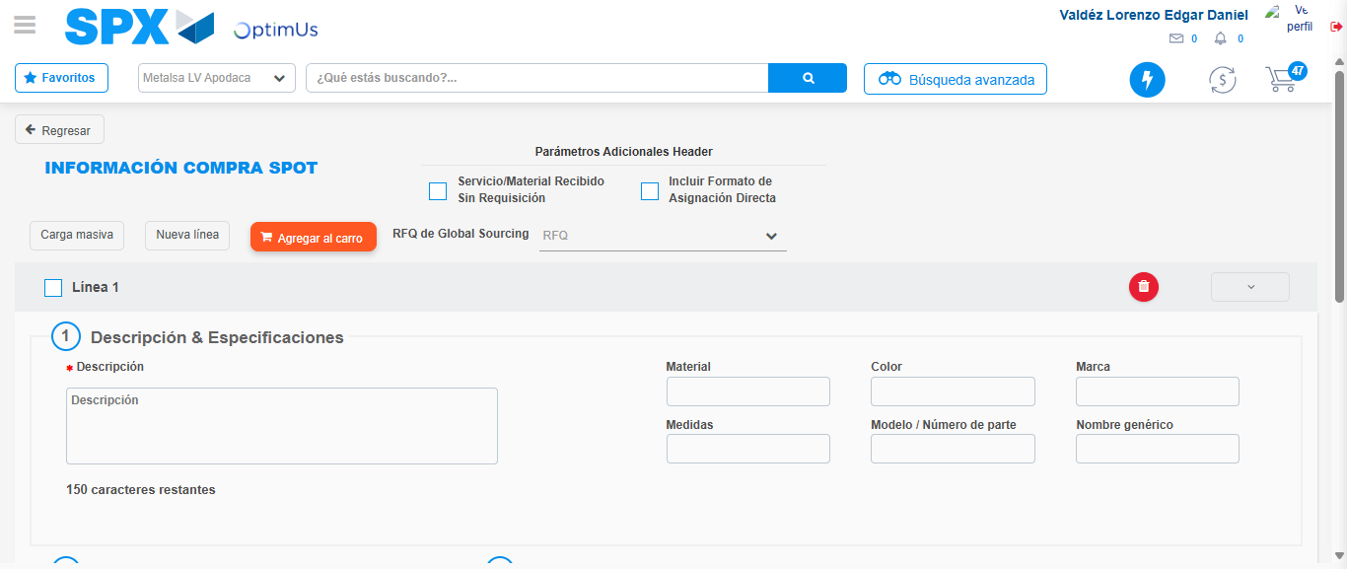Image file-name: QC_Testing-tc001_SPX_Dev5_Crear_Nueva_Linea_Requisicion_Spot_Tipo_Cobro_CC-1781316282161

Step 3 - Data Capture Spot Buy Requisition: Data captured correctly
Image file-name: QC_Testing-tc001_SPX_Dev5_Crear_Nueva_Linea_Requisicion_Spot_Tipo_Cobro_CC-1781316282399

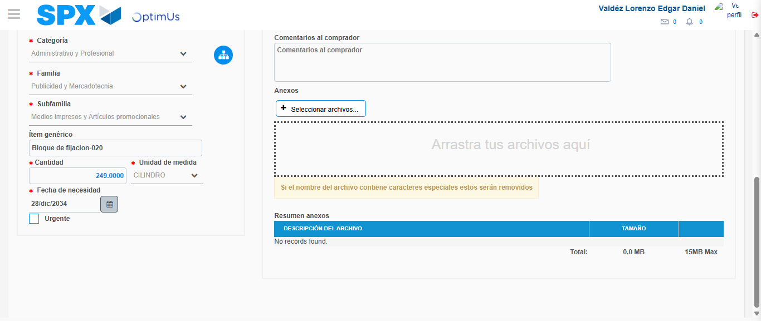Image file-name: QC_Testing-tc001_SPX_Dev5_Crear_Nueva_Linea_Requisicion_Spot_Tipo_Cobro_CC-1781316293711

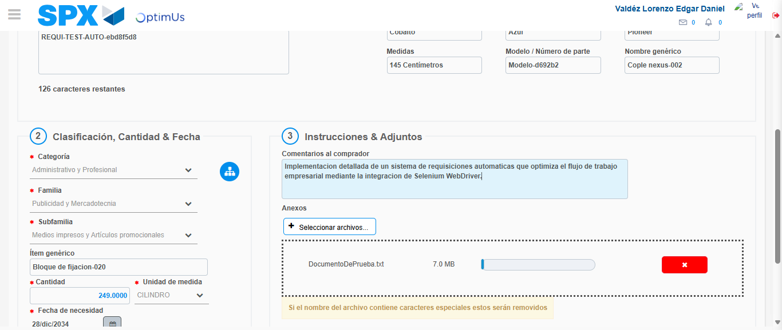Image file-name: QC_Testing-tc001_SPX_Dev5_Crear_Nueva_Linea_Requisicion_Spot_Tipo_Cobro_CC-1781316294510

Step 4 - Add new line and data capture second line: Line add correctly
Image file-name: QC_Testing-tc001_SPX_Dev5_Crear_Nueva_Linea_Requisicion_Spot_Tipo_Cobro_CC-1781316282399

Image file-name: QC_Testing-tc001_SPX_Dev5_Crear_Nueva_Linea_Requisicion_Spot_Tipo_Cobro_CC-1781316293711

Image file-name: QC_Testing-tc001_SPX_Dev5_Crear_Nueva_Linea_Requisicion_Spot_Tipo_Cobro_CC-1781316294510

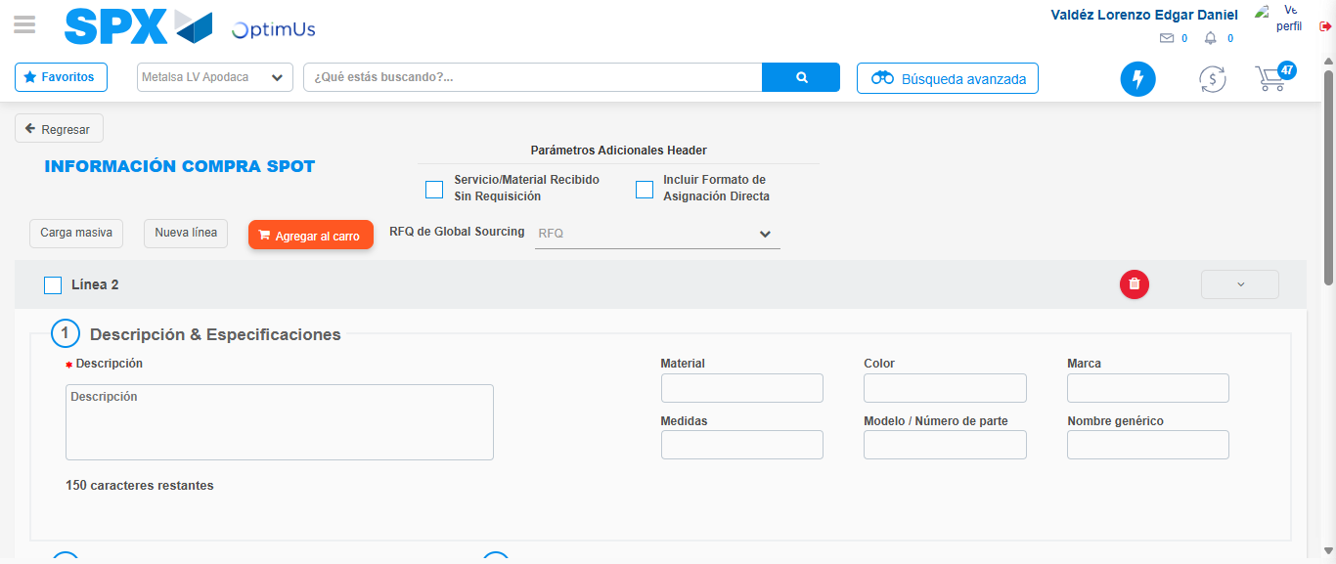Image file-name: QC_Testing-tc001_SPX_Dev5_Crear_Nueva_Linea_Requisicion_Spot_Tipo_Cobro_CC-1781316296820

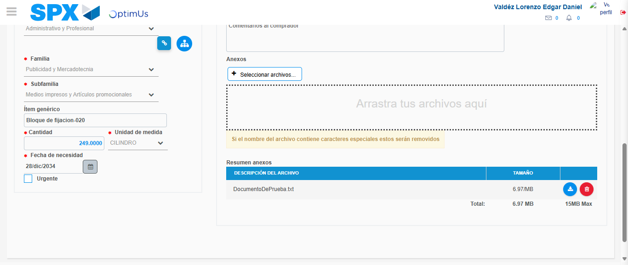Image file-name: QC_Testing-tc001_SPX_Dev5_Crear_Nueva_Linea_Requisicion_Spot_Tipo_Cobro_CC-1781316309074

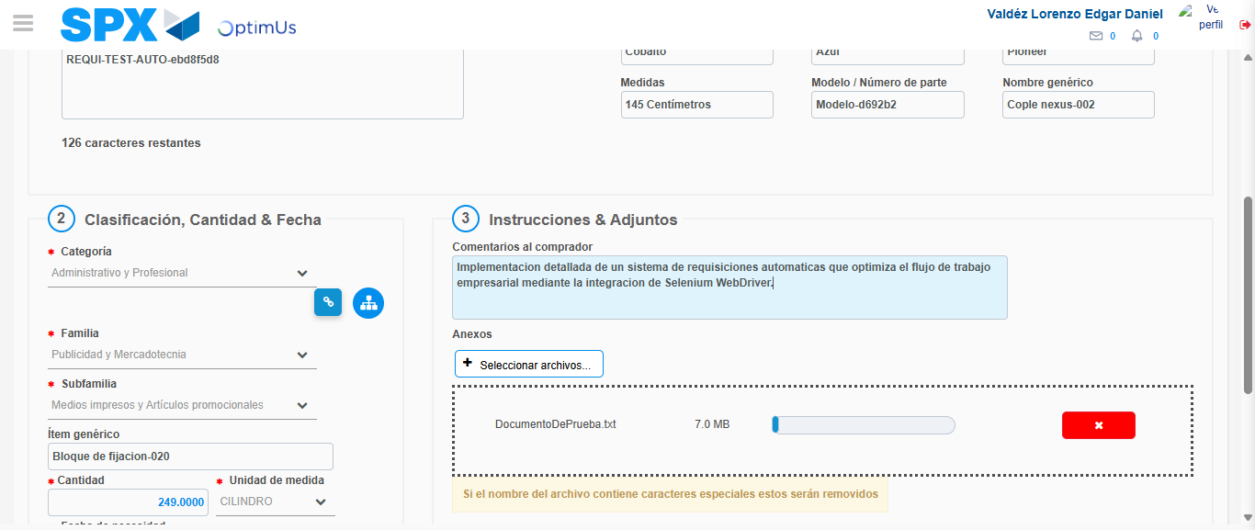Image file-name: QC_Testing-tc001_SPX_Dev5_Crear_Nueva_Linea_Requisicion_Spot_Tipo_Cobro_CC-1781316309864

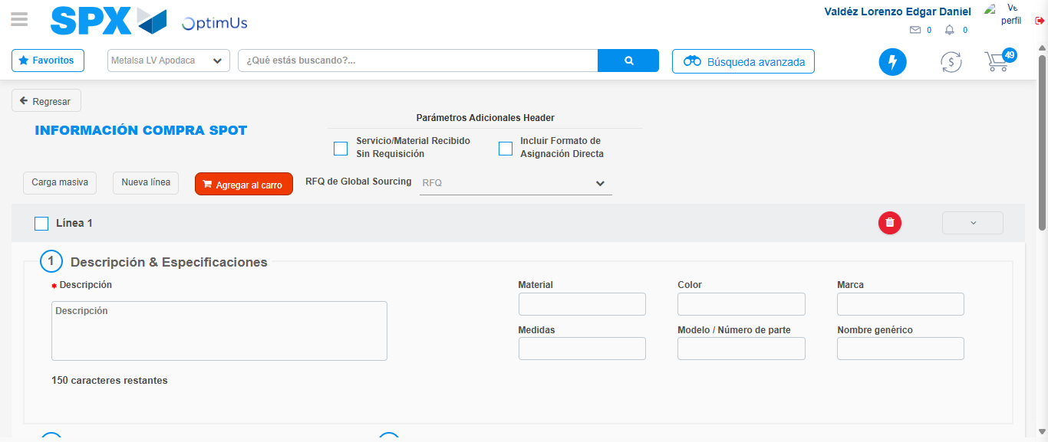Image file-name: QC_Testing-tc001_SPX_Dev5_Crear_Nueva_Linea_Requisicion_Spot_Tipo_Cobro_CC-1781316319422

Step 5 - Select to Requisition: Requisition Correctly selected
Image file-name: QC_Testing-tc001_SPX_Dev5_Crear_Nueva_Linea_Requisicion_Spot_Tipo_Cobro_CC-1781316319610

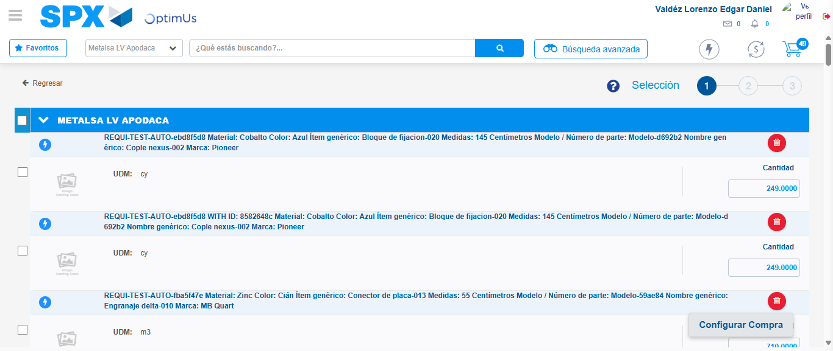Image file-name: QC_Testing-tc001_SPX_Dev5_Crear_Nueva_Linea_Requisicion_Spot_Tipo_Cobro_CC-1781316324415

Image file-name: QC_Testing-tc001_SPX_Dev5_Crear_Nueva_Linea_Requisicion_Spot_Tipo_Cobro_CC-1781316324638

Image file-name: QC_Testing-tc001_SPX_Dev5_Crear_Nueva_Linea_Requisicion_Spot_Tipo_Cobro_CC-1781316324835

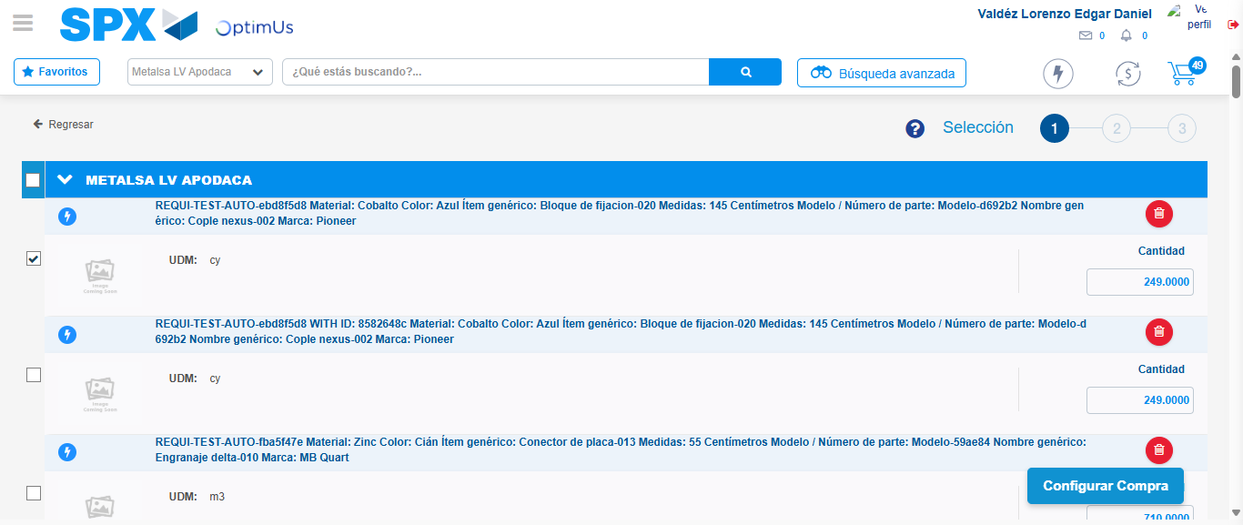Image file-name: QC_Testing-tc001_SPX_Dev5_Crear_Nueva_Linea_Requisicion_Spot_Tipo_Cobro_CC-1781316325743

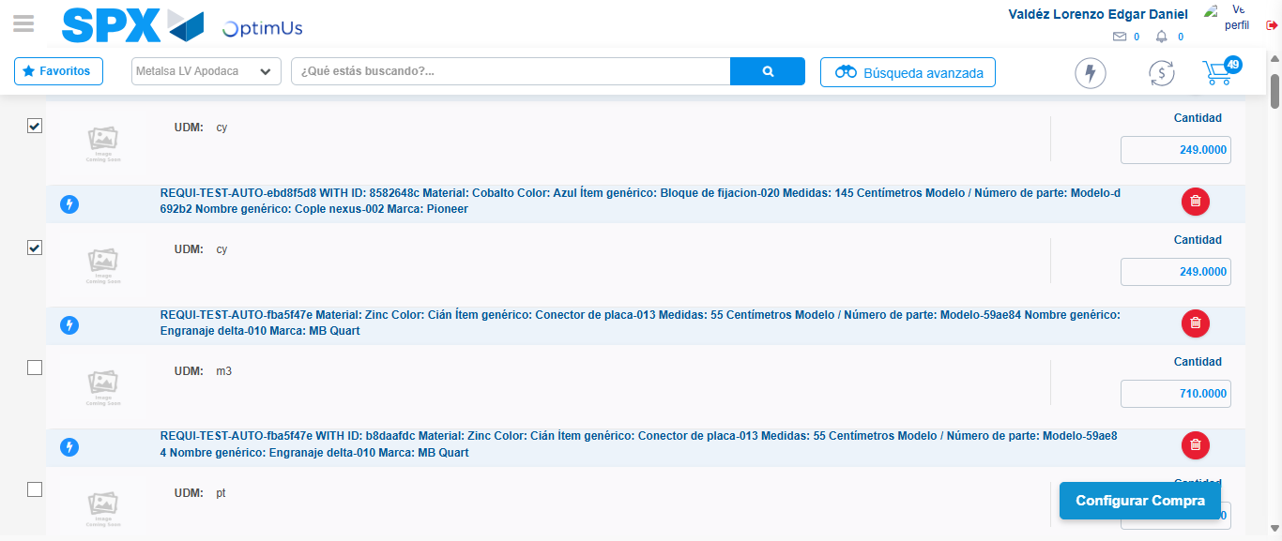Image file-name: QC_Testing-tc001_SPX_Dev5_Crear_Nueva_Linea_Requisicion_Spot_Tipo_Cobro_CC-1781316326623

Step 6 - Select Type Account For Requisition: Type Account Correctly selected
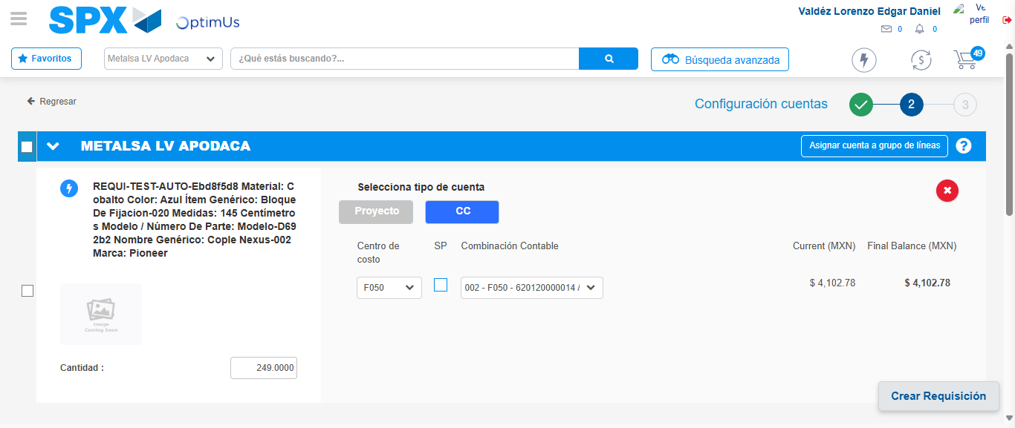Image file-name: QC_Testing-tc001_SPX_Dev5_Crear_Nueva_Linea_Requisicion_Spot_Tipo_Cobro_CC-1781316357184

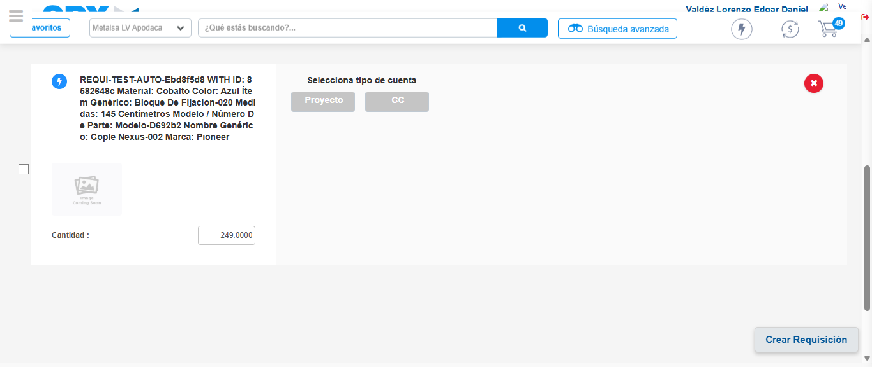Image file-name: QC_Testing-tc001_SPX_Dev5_Crear_Nueva_Linea_Requisicion_Spot_Tipo_Cobro_CC-1781316367595

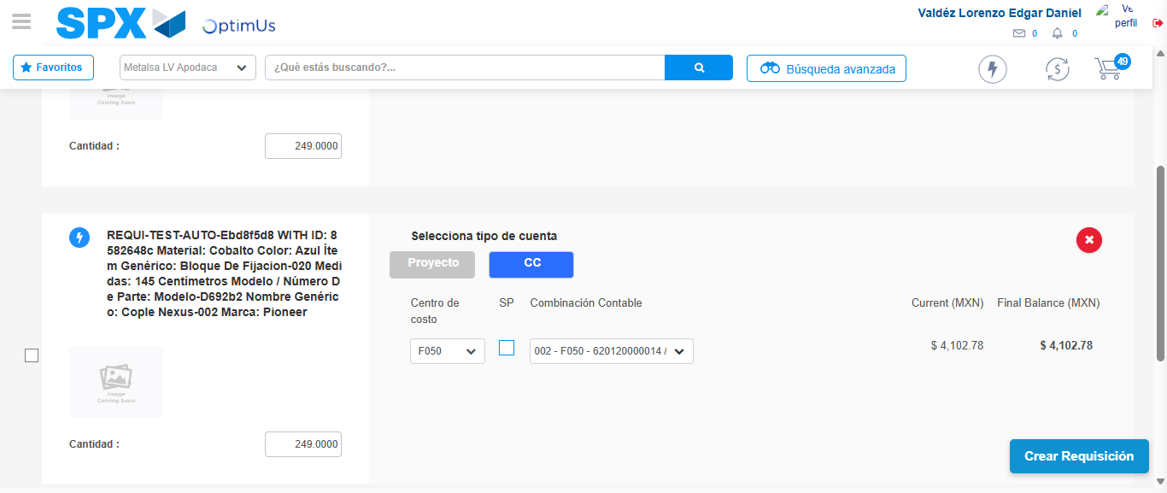Image file-name: QC_Testing-tc001_SPX_Dev5_Crear_Nueva_Linea_Requisicion_Spot_Tipo_Cobro_CC-1781316382431

Image file-name: QC_Testing-tc001_SPX_Dev5_Crear_Nueva_Linea_Requisicion_Spot_Tipo_Cobro_CC-1781316386813

Image file-name: QC_Testing-tc001_SPX_Dev5_Crear_Nueva_Linea_Requisicion_Spot_Tipo_Cobro_CC-1781316387013

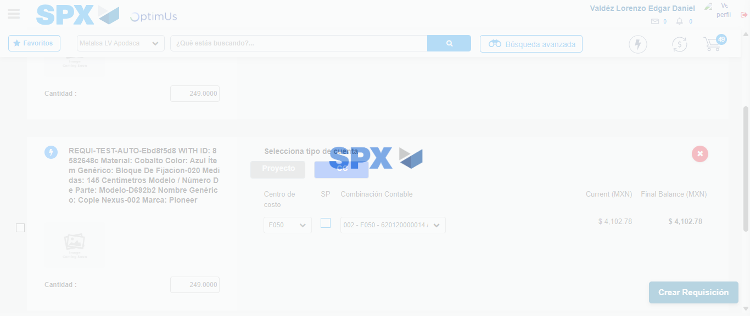Image file-name: QC_Testing-tc001_SPX_Dev5_Crear_Nueva_Linea_Requisicion_Spot_Tipo_Cobro_CC-1781316387363

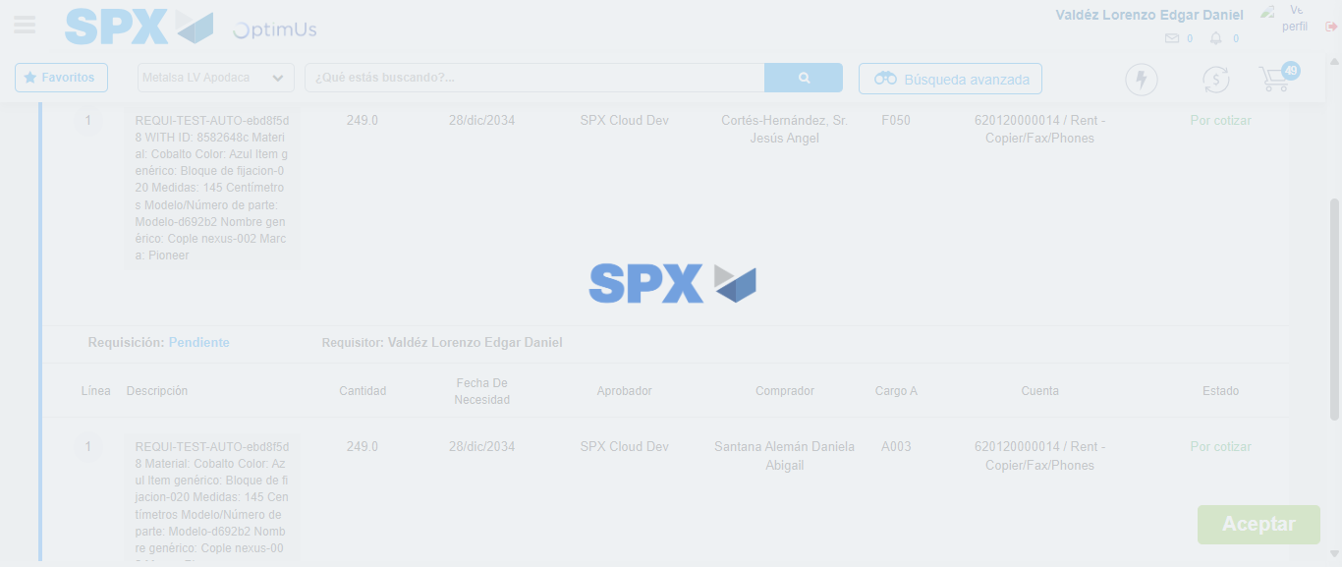Image file-name: QC_Testing-tc001_SPX_Dev5_Crear_Nueva_Linea_Requisicion_Spot_Tipo_Cobro_CC-1781316387604

Step 7 - Accept to Requisition: Requisition Accepted
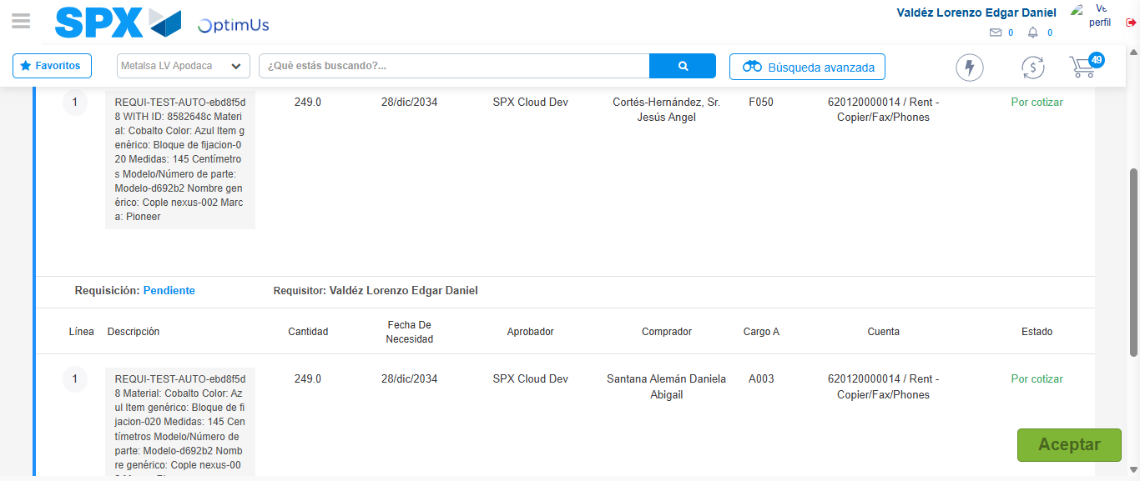Image file-name: QC_Testing-tc001_SPX_Dev5_Crear_Nueva_Linea_Requisicion_Spot_Tipo_Cobro_CC-1781316388369

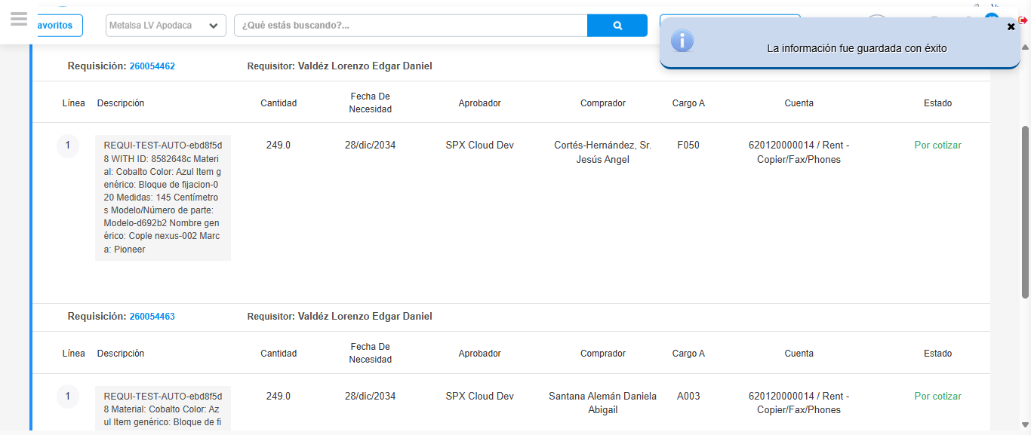Image file-name: QC_Testing-tc001_SPX_Dev5_Crear_Nueva_Linea_Requisicion_Spot_Tipo_Cobro_CC-1781316390768

Step 8 - Return to Main Page SPX : Return to Main Page SPX
Image file-name: QC_Testing-tc001_SPX_Dev5_Crear_Nueva_Linea_Requisicion_Spot_Tipo_Cobro_CC-1781316245380

Image file-name: QC_Testing-tc001_SPX_Dev5_Crear_Nueva_Linea_Requisicion_Spot_Tipo_Cobro_CC-1781316248005

Image file-name: QC_Testing-tc001_SPX_Dev5_Crear_Nueva_Linea_Requisicion_Spot_Tipo_Cobro_CC-1781316282161

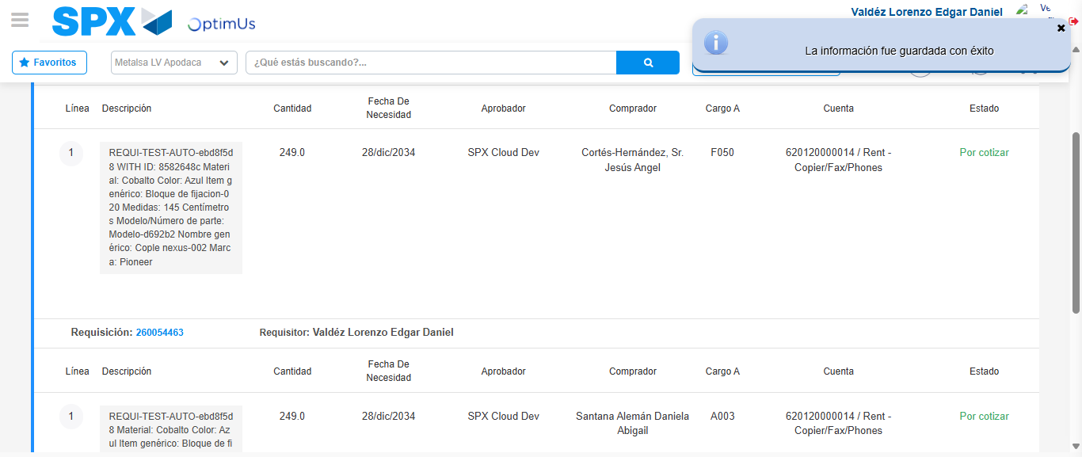Image file-name: QC_Testing-tc001_SPX_Dev5_Crear_Nueva_Linea_Requisicion_Spot_Tipo_Cobro_CC-1781316392999

Image file-name: QC_Testing-tc001_SPX_Dev5_Crear_Nueva_Linea_Requisicion_Spot_Tipo_Cobro_CC-1781316393176

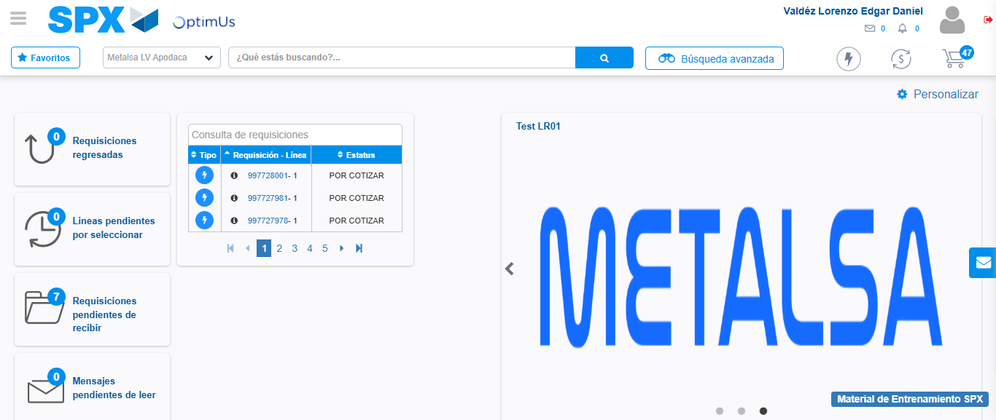Image file-name: QC_Testing-tc001_SPX_Dev5_Crear_Nueva_Linea_Requisicion_Spot_Tipo_Cobro_CC-1781316414235

Step 9 - Log Out : Log Out SPX
Image file-name: QC_Testing-tc001_SPX_Dev5_Crear_Nueva_Linea_Requisicion_Spot_Tipo_Cobro_CC-1781316414487

